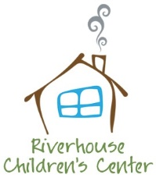
Riverhouse Infant Food Program
The Riverhouse Food Program is designed to introduce new foods into your child’s diet and to provide a healthy, nutritional lunch time meal supplement. At 12 months old your child is now invited to participate in our food program.
If your child has dietary restrictions we can incorporate these needs and it may still be necessary for you to provide substitutions. We are a peanut-free facility and we do not serve shellfish. We will not introduce meat/fish until you have done so at home.

My child ____________________________ may be given Riverhouse’s lunches with:
____ No restrictions
____ Meat (allergy/preference)
____ Fish (allergy/preference)
____ Dairy (allergy/preference)
____ Soy (allergy/preference)
____ Gluten (allergy/preference)
____ Other (please explain in detail) _______________________________________________________
__________________________________________________________________________________________________________________________________________________________________________
Please specify if your choice is an allergy or preference.

Have you introduced meat? If so, what types? _____________________________________________
Have you introduced fish? If so, what types? ______________________________________________
I understand that this is a supplement to foods that I will bring. This food program only covers lunch time and it is my duty to bring a variety of healthy foods for AM and PM snack, as well as jar foods/foods from home until my child is ready to eat only table food for lunch.
_______________________________________ _______________
Signature Date

